Power Consumption (Single motor) 5 Minutes

- The microcontroller converted the raw analog data into milliamp (mA) readings every 1,000 milliseconds and exported the data via serial communication for a period of 5 minutes.

Results & Data Logging

Timestamp (s) | Raw Sensor Value (A0) | Calculated Current (mA)

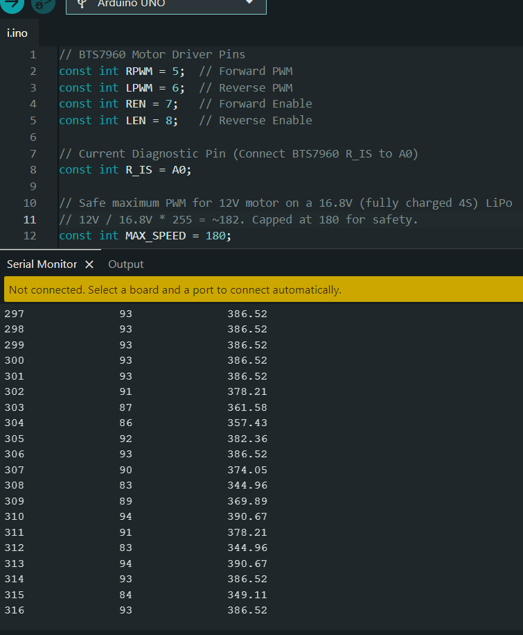

Data Analysis
During the recorded window, the single JGB37-520 motor exhibited an average current draw of 375.4 mA
Batter Capacity Before Testing:
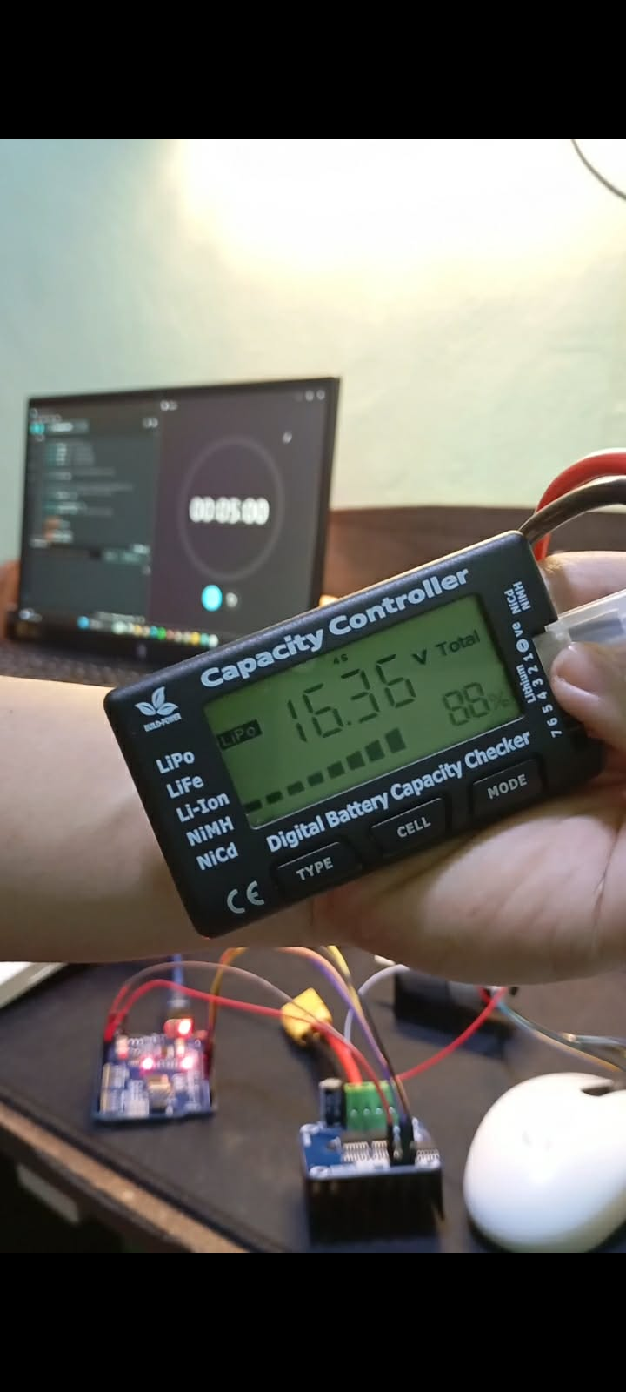
Batter Capacity After Testing:
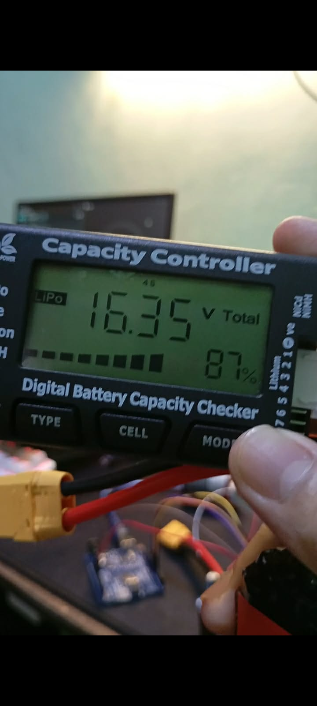
- Losing only 1% of a 6000mAh battery during a sustained 5-minute stress test means the motor consumed roughly 60mAh in total.

